Great Basin Native Artists

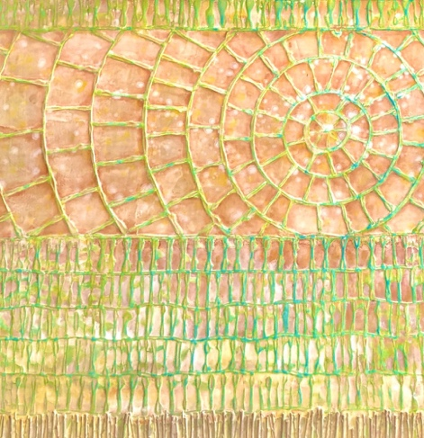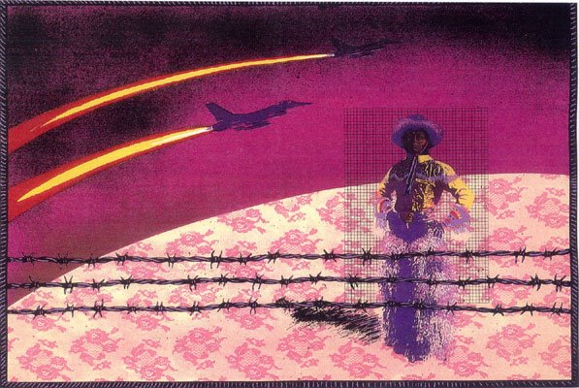

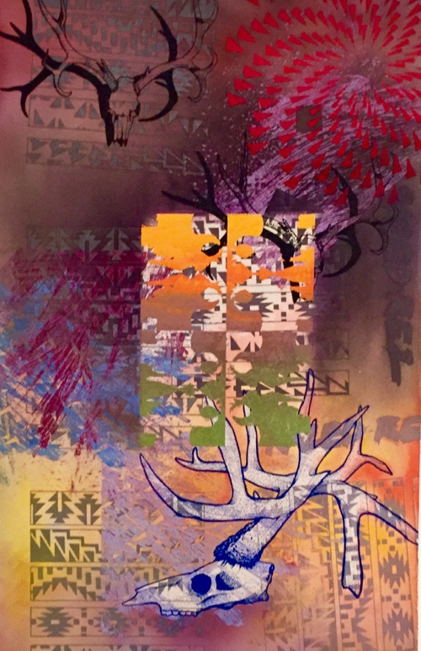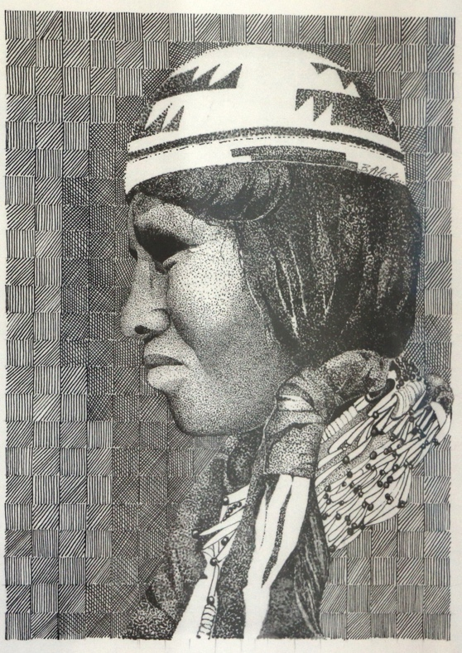
Map of the Great Basin
The Great Basin Native Artists collective are Indigenous artists living in/or originally from the Great Basin areas of Nevada, California, Southern Oregon, Southern Idaho, and Utah.

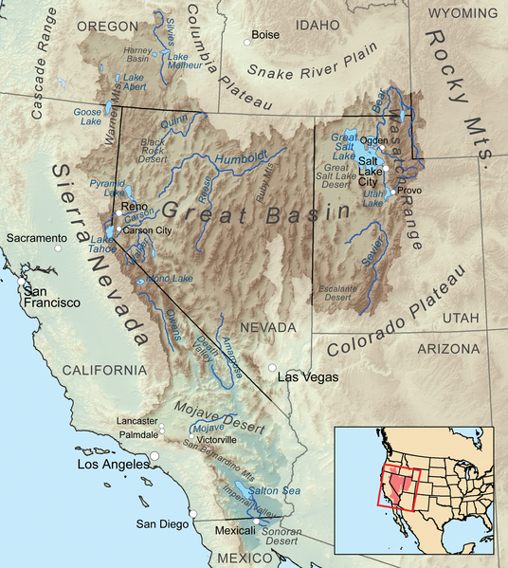

The Great Basin region has a large population of Native peoples with rich contemporary arts and cultures. Nevada is home to 32 tribal communities consisting mostly of the Paiute (pī′yo͞ot′) (Northern and Southern), Shoshone (shō-shō′nē), and the Washoe (wosh′ō).
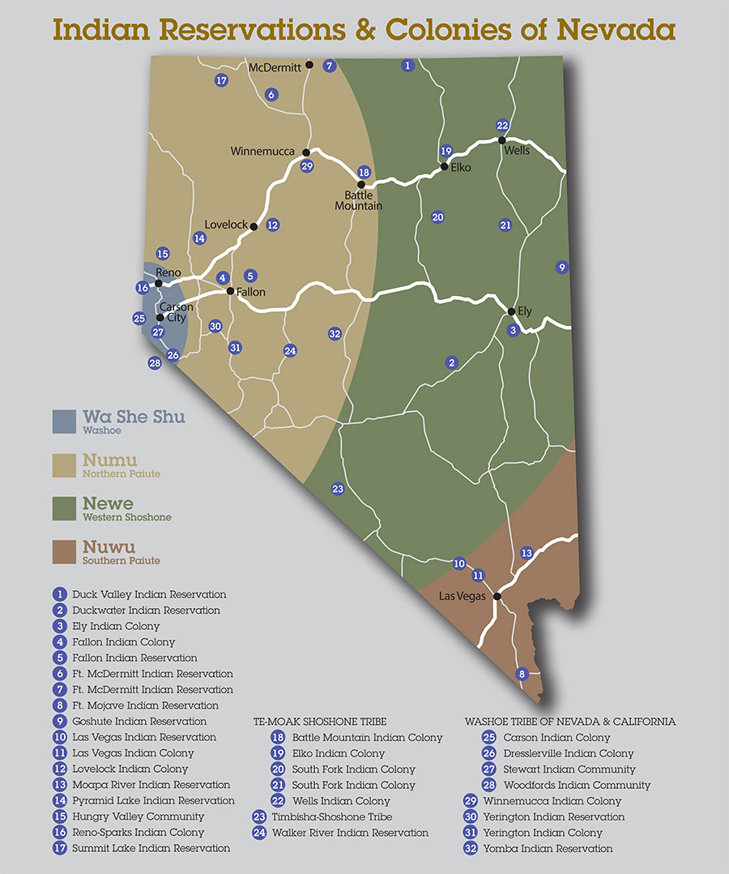

Native Art Past and Present
There are currently 574 federally recognized Native American tribes in the United States. Each tribe is unique with its own language, stories, belief systems, art, and cultural identity. Although art forms and styles vary from region to region and tribe to tribe, historically many Native peoples integrated design into daily life. Beauty was incorporated in utensils, tools, clothing, shelter, religious objects, and everything in between. Art served not only an aesthetic purpose but was simultaneously spiritual and utilitarian. Native peoples mastered varying combinations of abstraction and representation. Natural materials from the environment were used as well as foreign materials traded from far away tribes and eventually settlers from across the ocean. Today Native artists continue to adapt, utilizing contemporary resources, as they reflect on their personal experience and Native identity.
Current map of North American Tribal Regions (not all tribes):
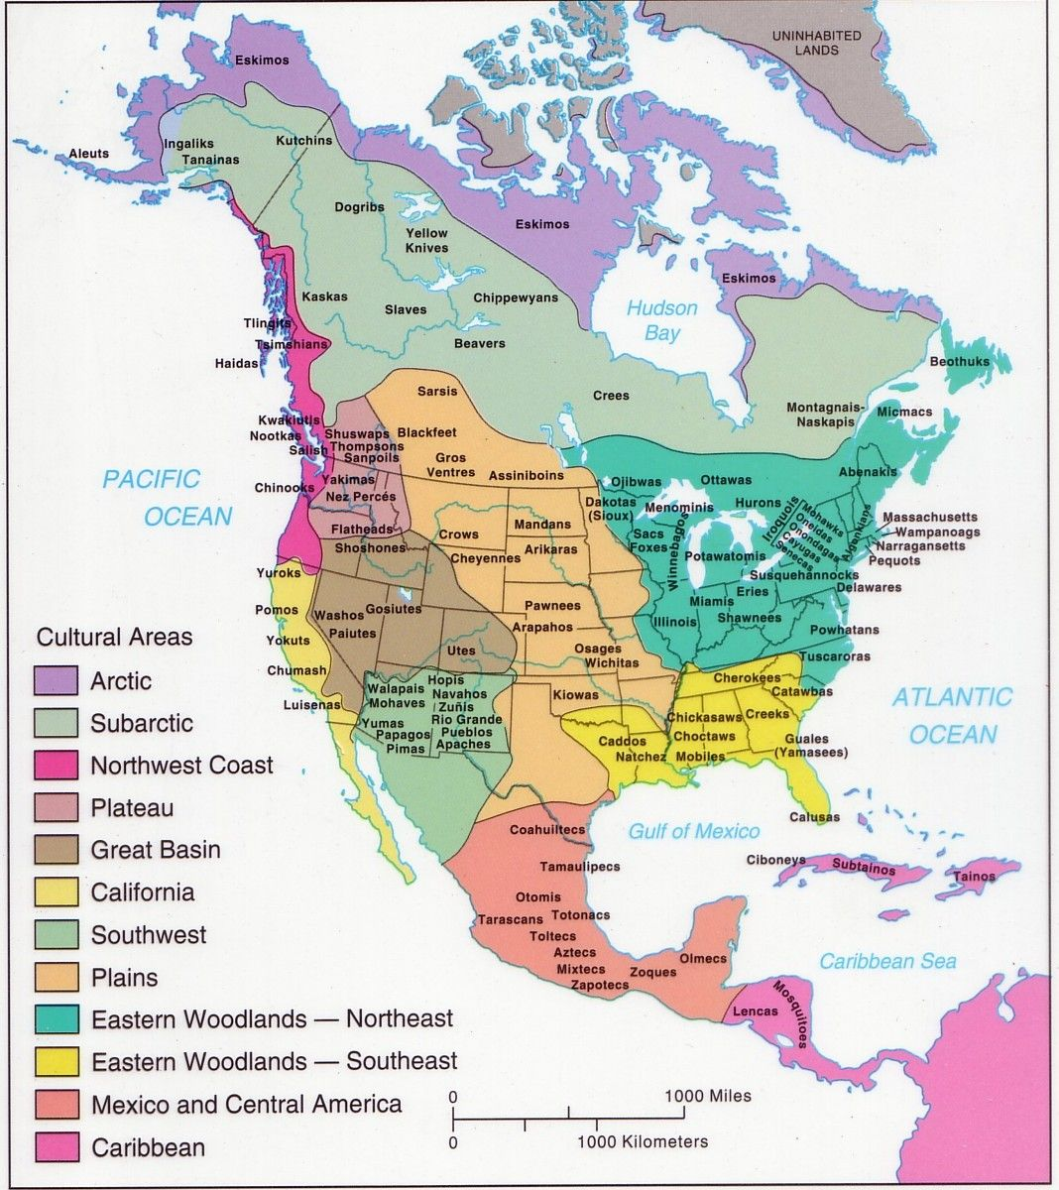
References:

Native American History:

https://americanindian.si.edu/nk360

https://illuminative.org/resources/

An Indigenous Peoples' History of the United States (REVISIONING HISTORY)
The Boarding School Tragedy:

https://boardingschoolhealing.org/curriculum/

https://americanindian.si.edu/education/codetalkers/html/chapter3.html

https://secureservercdn.net/198.71.233.135/ee8.a33.myftpupload.com/wp-content/uploads/2020/07/2020-MAP-1500px.jpg

Nevada Native history:

https://digital.library.upenn.edu/women/winnemucca/piutes/piutes.html

http://www.rsic.org/rsic-history/

https://www.temoaktribe.com/history.shtml

https://washoetribe.us/aboutpage/4-Page-washoe-history

https://stewartindianschool.com/museum/
Contemporary Native Art:

https://www.pbs.org/video/native-art-now-vbtkzs/

https://firstamericanartmagazine.com/references/artist_list/

https://www.khanacademy.org/humanities/ap-art-history/indigenous-americas-apah/north-america-apah/a/terms-and-issues-in-native-american-art

https://notartomatic.wordpress.com/2010/04/11/what-is-so-important-about-native-american-art/

Great Basin Native Artists
The Great Basin Native Artists (GBNA) is an organization consisting of professional and emerging Indigenous artists, residing in/or originally from the Great Basin areas of Nevada, California, Southern Oregon, Southern Idaho, and Utah.
GBNA is also a movement to educate our artists and our community about Great Basin Native art in our region by providing:
- Exhibiting opportunities as a group for local, national, and international
Native/Indigenous art exhibitions
- Cultural arts education to the Native and non-Native community
- Art business workshops for professional and emerging Indigenous artists
- Forum for Native artists and interested community members to connect
- Great Basin Native Artists archive directory and online database coming to the Nevada Museum of Art, 2021
Links:
Great Basin Native Artists (GBNA) website
First American Art Magazine article, Great Basin Native Artists
Ben Aleck, Artist profile, First American Art Magazine
Jean LaMarr, Artist profile, GBNA website
Jack Malotte, Artist profile, GBNA website
Melissa Melero-Moose, Artist profile, First American Art Magazine
Melissa Melero-Moose, Artist website

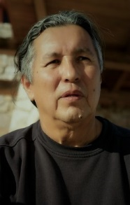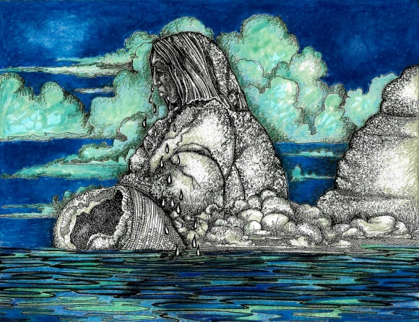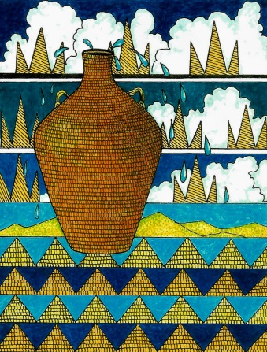

Ben Aleck – Contemporary painter and illustrator

Ben is a member of the Pyramid Lake Paiute Tribe (Numu Kooyooe Tukadu) of Nevada and is presently living in Nixon, Nevada.

Ben received his formal education in art at the California College of Art formerly the California College of Arts and Crafts located in Oakland, California. He graduated in 1972 receiving a Bachelor in Fine Arts Degree majoring in Painting.

Ben’s early work consisted of mainly oil painting utilizing the human figure as subject matter. His recent work consists of drawings using pen and ink and graphite on paper. The human figure is still a major theme in his work; however, he has the ability to incorporate a variety of materials and subjects in his work.

His current work is mixed media using water-base paint, ink, dyes, and natural materials. The subject matter consists of statements relating to cultural issues and environmental concerns.
He has participated in several group shows in Nevada and other Western states. His work has been shown at the Oakland Museum, Oakland, CA; Smithsonian Institute, Washington D.C.; Stewart Indian School Cultural Center and Museum, Carson City, Nevada and the Nevada Museum of Art, Reno, Nevada.

Links:

https://www.newsreview.com/reno/in-clear-view/content?oid=28871416

https://nevadamagazine.com/issue/may-june-2017/6699/

https://issuu.com/firstamericanartmagazine/docs/faam0_complete/61

https://newsstand.joomag.com/en/first-american-art-magazine-no-2-spring-2014/0428663001394511395

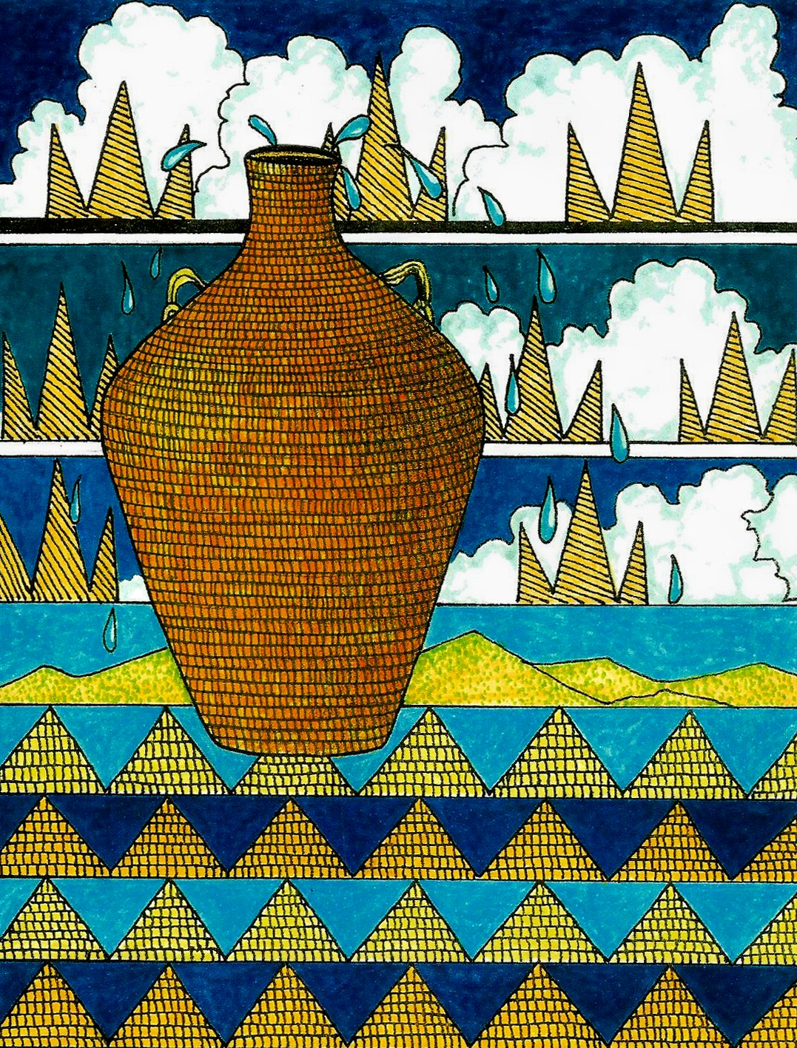

Ben Aleck, Water Jug
Pen, ink and watercolor on paper, 30” L x 24” W
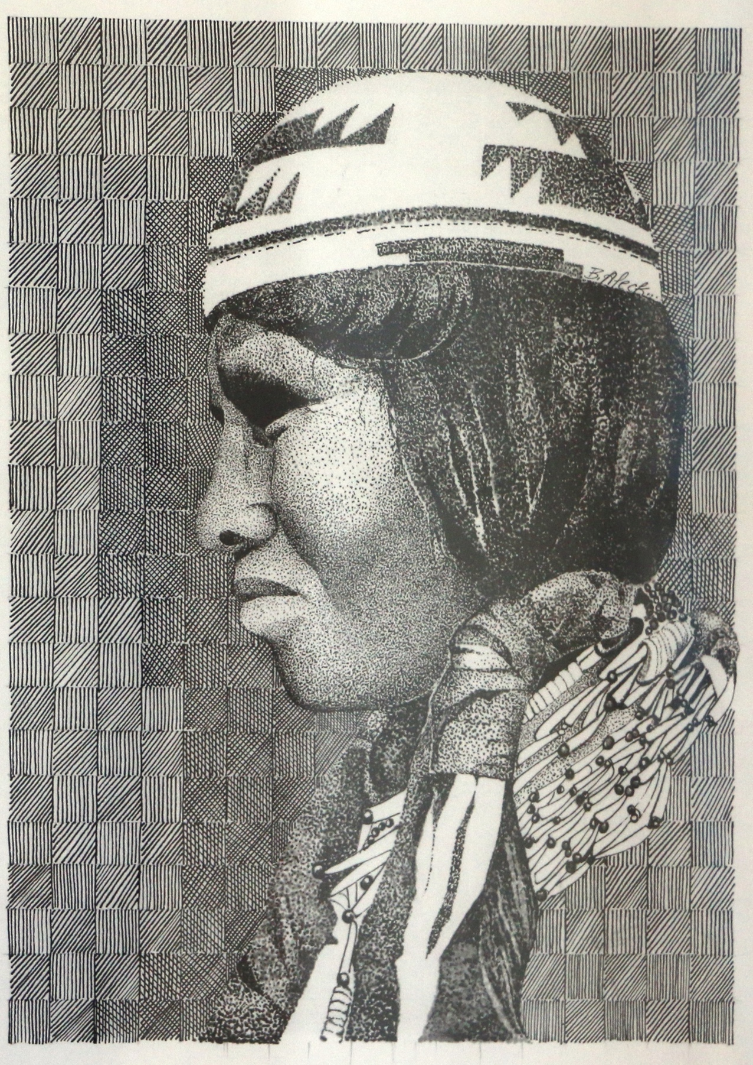
Ben Aleck, Basket Hat Woman
pencil and graphite on paper, 30” L x 24” W

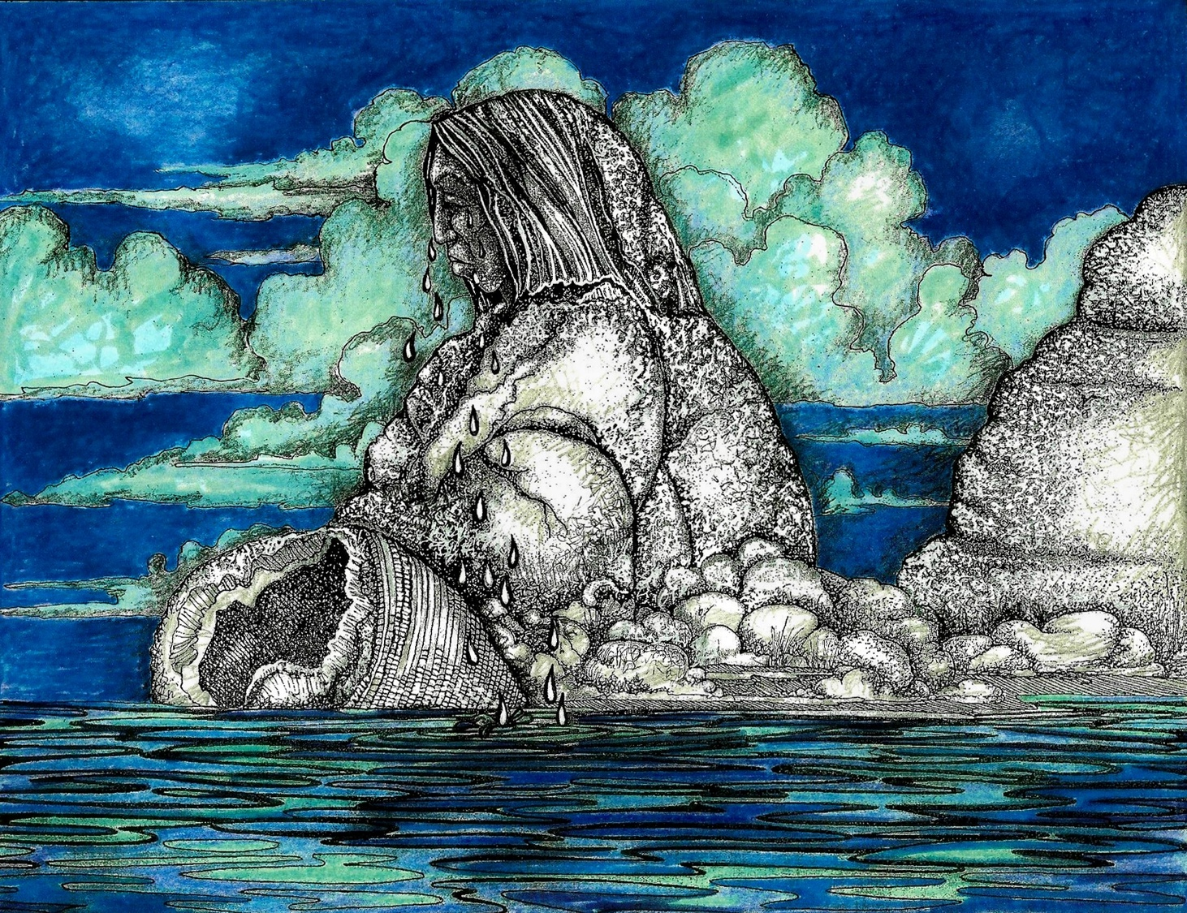
Ben Aleck, Stone Mother at Pyramid Lake
mixed media on paper, 24” L x 30” W

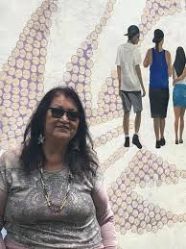

Jean LaMarr - printmaker and painter

Paiute and Pit River artist, Jean LaMarr, lives on the Susanville Indian Rancheria in northeastern California, where she directs the Native American Graphic Workshop. She studied art at UC Berkeley and has taught studio art at the Institute for American Indian Arts in Santa Fe, New Mexico and the California College of Arts and Crafts in Oakland, California.

LaMarr describes herself as a community artist-activist. Her printmaking follows personal and community ideals of making art and its messages accessible through copies made in printmaking.
Her artistic development was critically influenced by the Third World strike at UC Berkeley in 1969 as well as other political events in the early 1970s. LaMarr recalls balancing her activism with her formal art training at UC Berkeley's art department.

Her painting We Danced We Sang Until the Matron Came is a monoprint with an image of a sad little girl in the forefront and other little girls with the same chopped off haircut in the background on a fountain. The fountain is the same from the Stewart Indian School where LaMarr’s relatives attended Indian Boarding School in which Indigenous children were sent forcibly to assimilate into American society.
Links:
https://www.culturalsurvival.org/publications/cultural-survival-quarterly/interview-jean-lamarr-supporting-native-pride-native
https://www.moma.org/artists/66166
https://www.ucdavis.edu/news/work-native-american-printmaker-jean-lamarr-display/
https://americanindian.si.edu/exhibitions/indian_humor/toc/index.htm
https://en.wikipedia.org/wiki/Jean_LaMarr

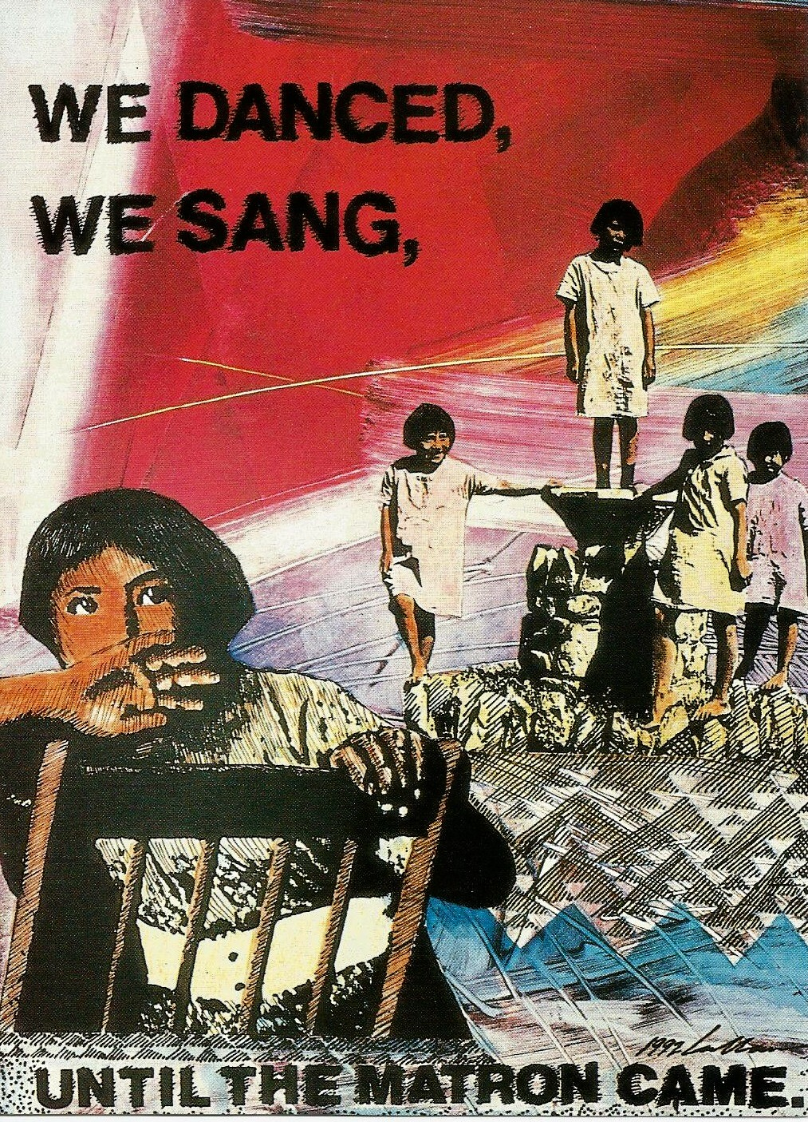

Jean LaMarr, We Danced, We Sang Until the Matron Came
Monoprint on archival paper

Jean LaMarr, Some Kind of Buckaroo
Lithograph on archival paper

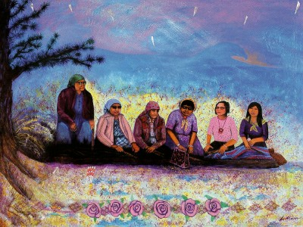
Jean Lamarr, Ni yak way (DOWN)
Acrylic on canvas with mixed media, 36” L x 48” W

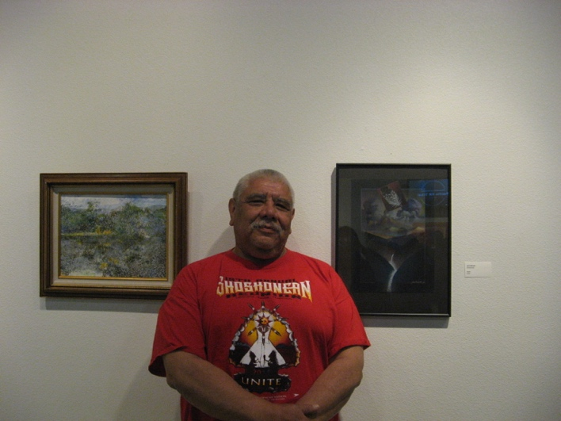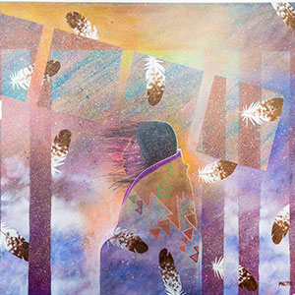
Jack Malotte, Graphic Artist & Illustrator
Jack Malotte, a Shoshone and Washoe artist and member of the South Fork Band of the Te-Moak Tribe of Western Shoshone Indians, grew up on the Reno-Sparks Indian Colony.
Malotte is a graduate of the California College of Arts and Crafts in Oakland, California. As a graphic artist and illustrator, his political themes convey contemporary Indigenous issues. He uses drawing, painting, and printmaking to convey his feelings about the “Indian connection with the earth and sky and how this connection manifests spiritually, physically, and politically.” He is best known for his satirical depictions of traditional Indians in a modern world, but the majority of his work depicts the arid Great Basin landscape of his ancestors. His work is exhibited widely across the nation and offers a timely reminder of the importance of the natural world and how tenuous is its protection.
Links:
https://www.nevadaart.org/art/exhibitions/jack-malotte/
https://www.youtube.com/watch?v=5wEgu3hKcQ4
https://www.cowboysindians.com/2019/09/art-gallery-jack-malotte/
https://www.juxtapoz.com/news/painting/a-conversation-with-jack-malotte/

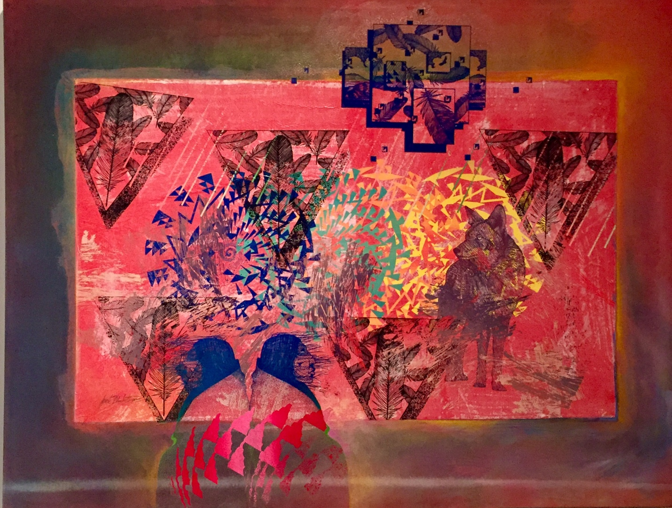
Jack Malotte, Coyote
Silkscreen on canvas, 36" H × 48" W

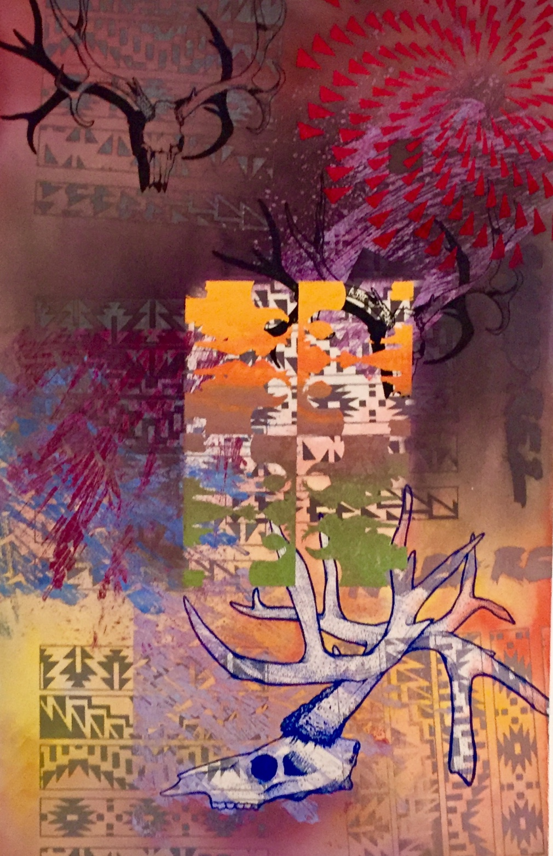
Jack Malotte, Dale’s Trophy
Screen-prints on canvas, 34” L x 22” W

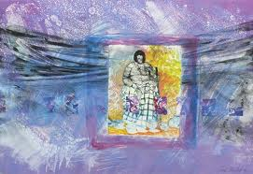
Jack Malotte, Dat So La Lee
Monoprint on archival paper, 32” H x 42” W

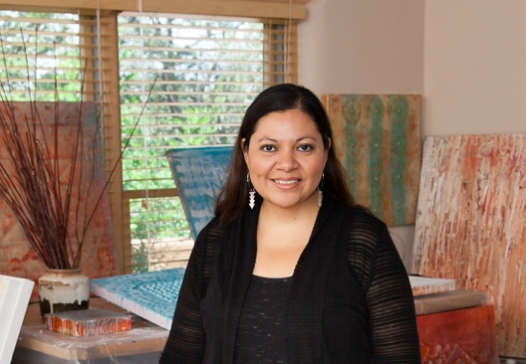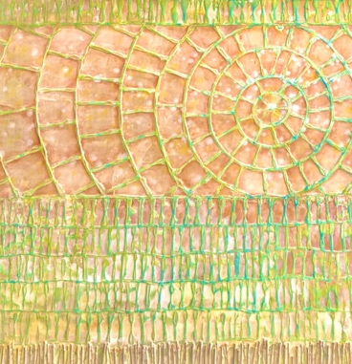
Melissa Melero-Moose – mixed-media painter and multidisciplinary artist
Melissa Melero-Moose is a mixed-media visual artist, mother, and a Northern Paiute enrolled with the Fallon Paiute-Shoshone Tribe. Melissa holds a Bachelor of Fine Art from the Institute of American Indian Arts, Santa Fe, New Mexico and a Bachelor of Science from Portland State University in Oregon. She exhibits her art regionally and nationally and has won numerous awards and acknowledgement for her work. She has received artist fellowships from the School for Advanced Research, Santa Fe, New Mexico; the Southwest Association of Indian Arts and the Wheelwright Museum in Santa Fe, New Mexico; the Nevada Museum of Art, Reno, Nevada; and the Institute of American Indian Arts, Santa Fe, New Mexico.
Melissa resides in Hungry Valley, Nevada working as a professional artist, contributing writer for First American Art Magazine and founder/curator of the art collective the Great Basin Native Artists (GBNA). She founded the organization in 2014 and, with help from fellow artist Ben Aleck, they started to reach out to other artists to organize art business workshops, exhibit group shows and educate the community about Great Basin tribal arts and culture.
She is currently putting together a comprehensive artist archive for the Great Basin Native Artists which will be permanently housed at the Nevada Museum of Art, Center for Art + Environment Research Library and online collections in Reno, Nevada.
Links:
www.melissamelero.com
https://sarweb.org/iarc/native-american-artist-fellowships/2015-artists/melissa-melero-moose/
https://www.nvartscouncil.org/programs/artist-services/lxs-2019/lxs-melissa-melero-moose/
https://www.newsreview.com/reno/in-clear-view/content?oid=28871416
https://en.wikipedia.org/wiki/Melissa_Melero-Moose
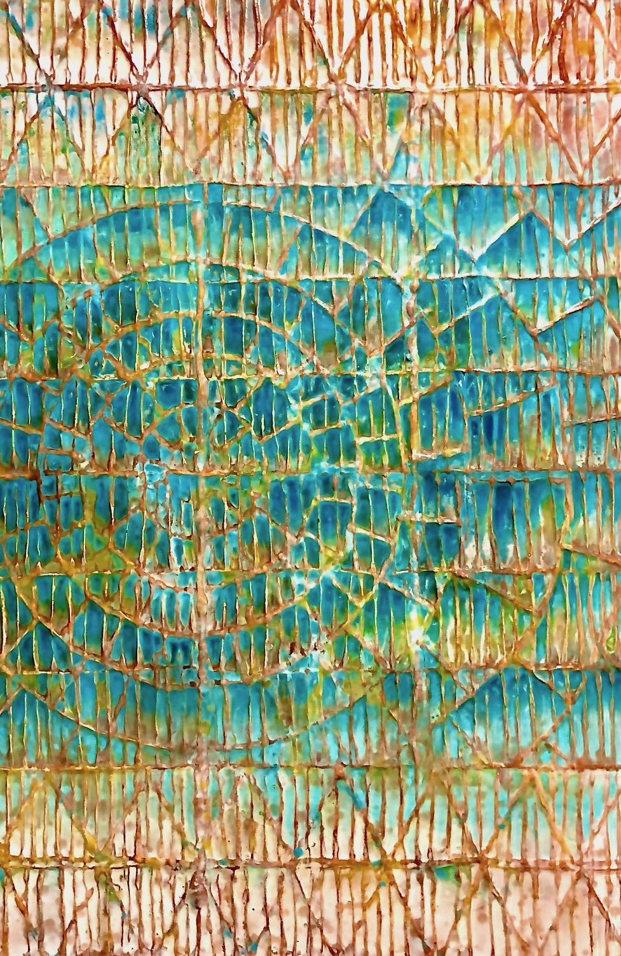
Melissa Melero-Moose, Creation of Wono (burden basket)
Mixed media on canvas, 48” H x 36” W

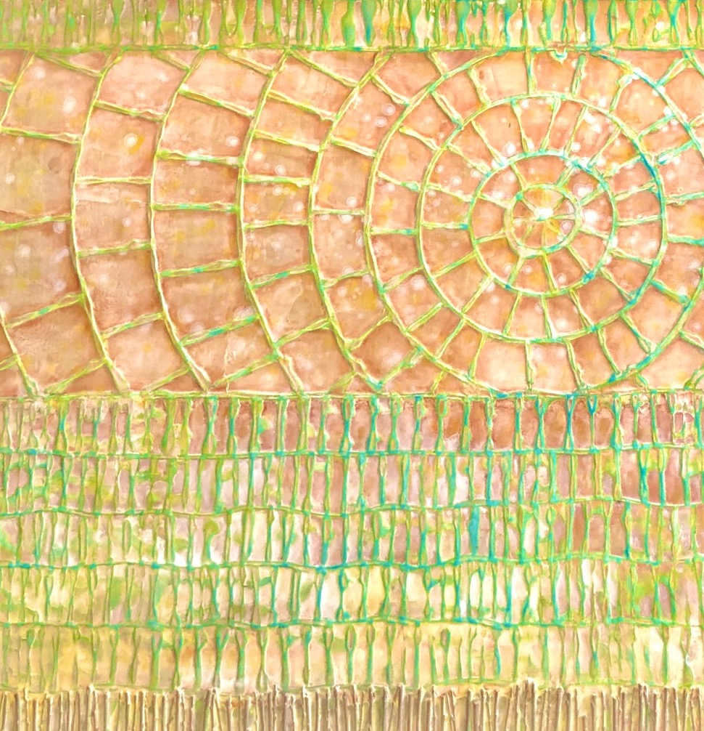
Melissa Melero-Moose, Her Place in Space
Mixed media with willow on canvas, 36” x 36”

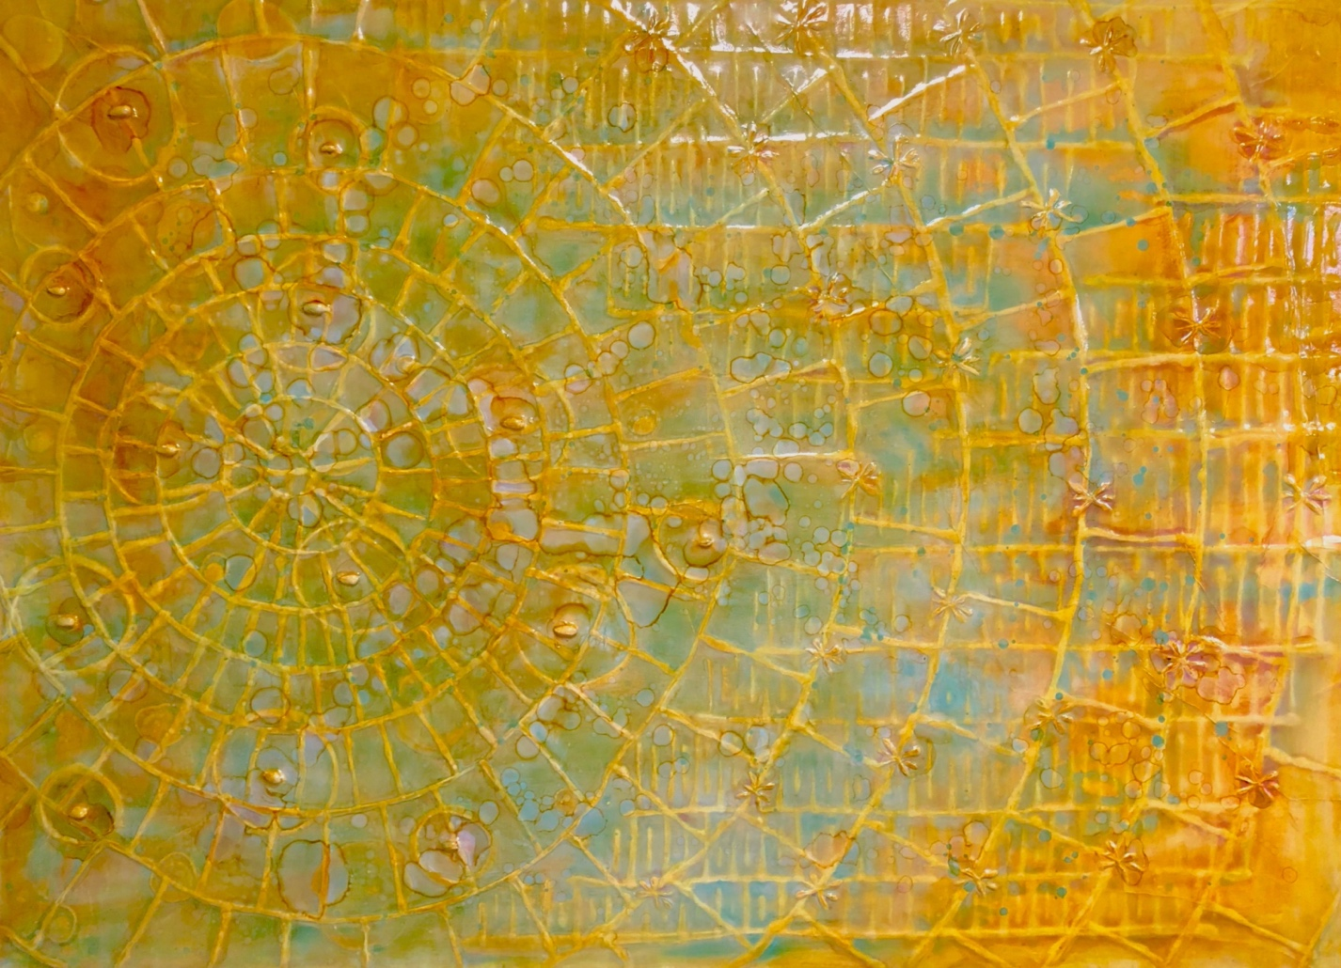
Melissa Melero-Moose, Access Denied
mixed media with pine nuts on canvas, 36” H x 48” W

Addressing Representation
- What do you think is happening in this piece?
- What story is the artist telling? What if anything is missing from that story?
- What seems real and what seems imagined in this artwork?
- What do you feel when you see this image, and why?
- How have non-Native artists represented Native American cultures?
- How have Native American artists represented their own cultures? What are the differences?
- What representations of Native Americans did you experience?
- Why was the artist interested in this subject matter?
- In what ways do these images shape our understanding of Native Americans?
- What other representations of Native Americans do you see outside the museum?

Contemporary Connections
- What material is this artist using? Why do you think they choose that material?
- Do we see these materials/patterns/forms in historical Native American art? Why or why not?
- How does this artwork relate to other artworks around it? How does it relate to artworks created by Native or non-Native artists?
- What is the artist communicating about themselves?
- Is the artist saying anything about their community?

*** resources and materials gathered by Melissa Melero-Moose, Great Basin Native Artists, 2020

